Part No | Description | Price £ UK

LK 103 | Workshop tools; - hammer, 2 x screwdrivers, hacksaw, pliers, engineers square and large engineers file | 4.40

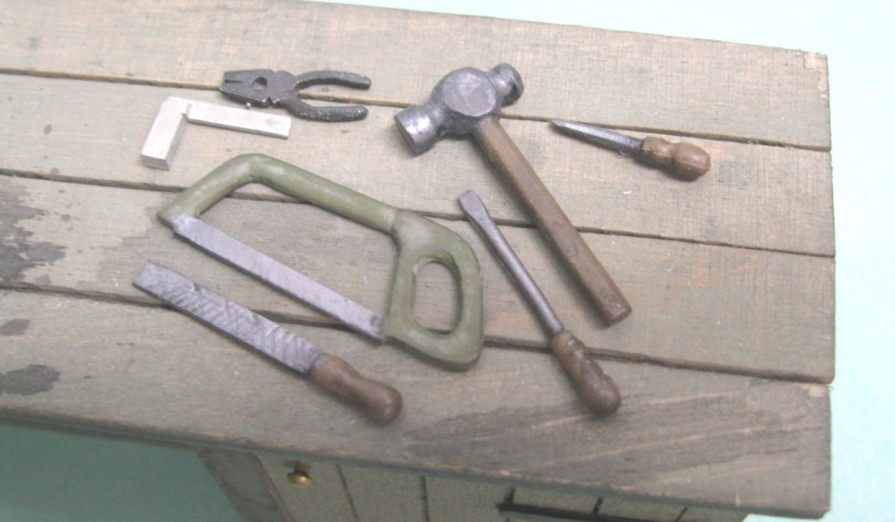

LK 104 | Bench Vice this builds into a neat heavy duty bench vice that can be bolted to a workbench or work trolley, the jaws can be made to slide out | 3.30

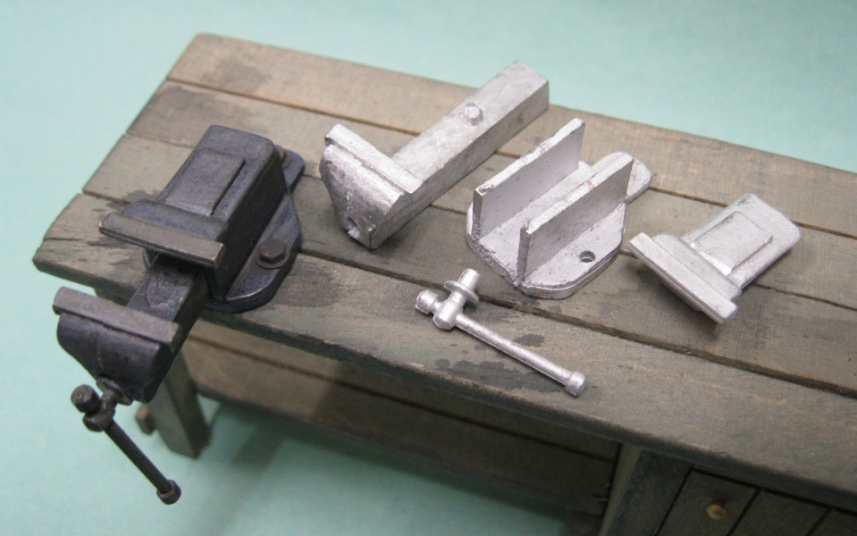

LK 105 | Oil Drum Tap and bung (drums not included) | 2.20
